Year 11 Protein Synthesis Validation

Name:________________________ /40

1. The process by which messenger RNA (mRNA) is produced is called:

___________________________________________________________________________(1 mark)

2. The process in which transfer RNA brings amino acids to the ribosome is called:

___________________________________________________________________________(1 mark)

3. Identify the similarities and differences between DNA and mRNA.

__________________________________________________________________________________

__________________________________________________________________________________

__________________________________________________________________________________

__________________________________________________________________________________

__________________________________________________________________________________

__________________________________________________________________________________

__________________________________________________________________________________

__________________________________________________________________________(5 marks)

4. How many amino acids does the following mRNA strand code for: (1 mark)

**AUGCCGAUUGCGACGUAGGCUAGC**

__________________________________________________________________________________

5. Define the difference between the template and coding strand.

__________________________________________________________________________________

__________________________________________________________________________________

__________________________________________________________________________________

__________________________________________________________________________(2 marks)

6. What are the two (2) main functions of RNA polymerase?

__________________________________________________________________________________

__________________________________________________________________________________

__________________________________________________________________________________

__________________________________________________________________________(2 marks)

7. Fill in the following table. (7 marks)

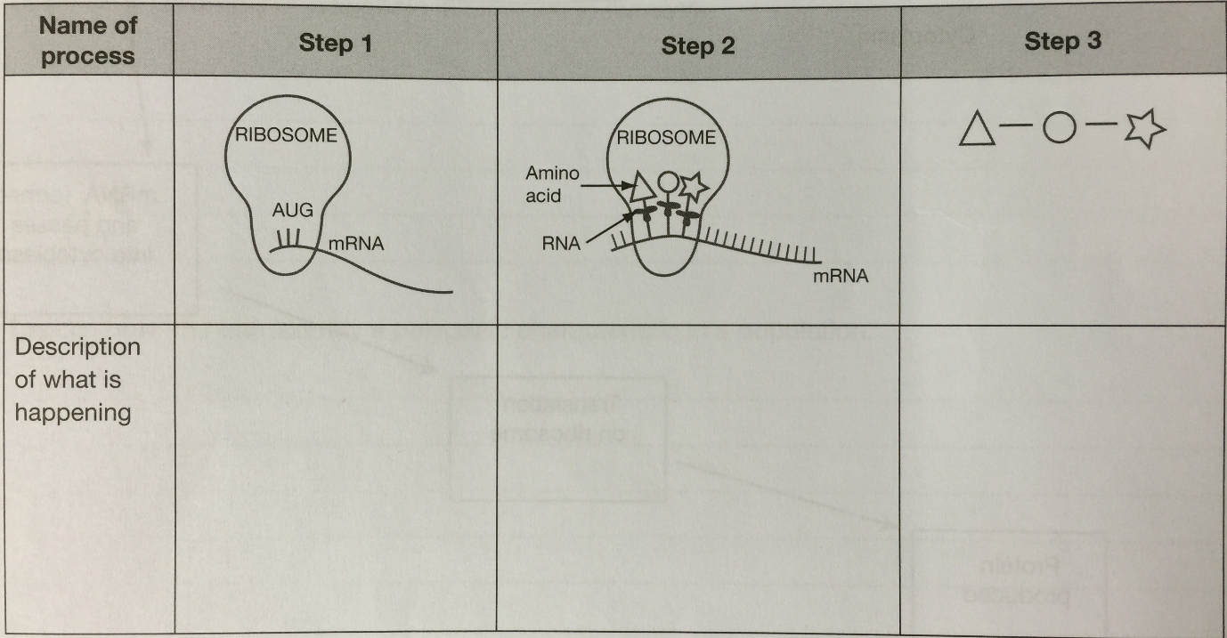

8. Fill in the following table. (7 marks)

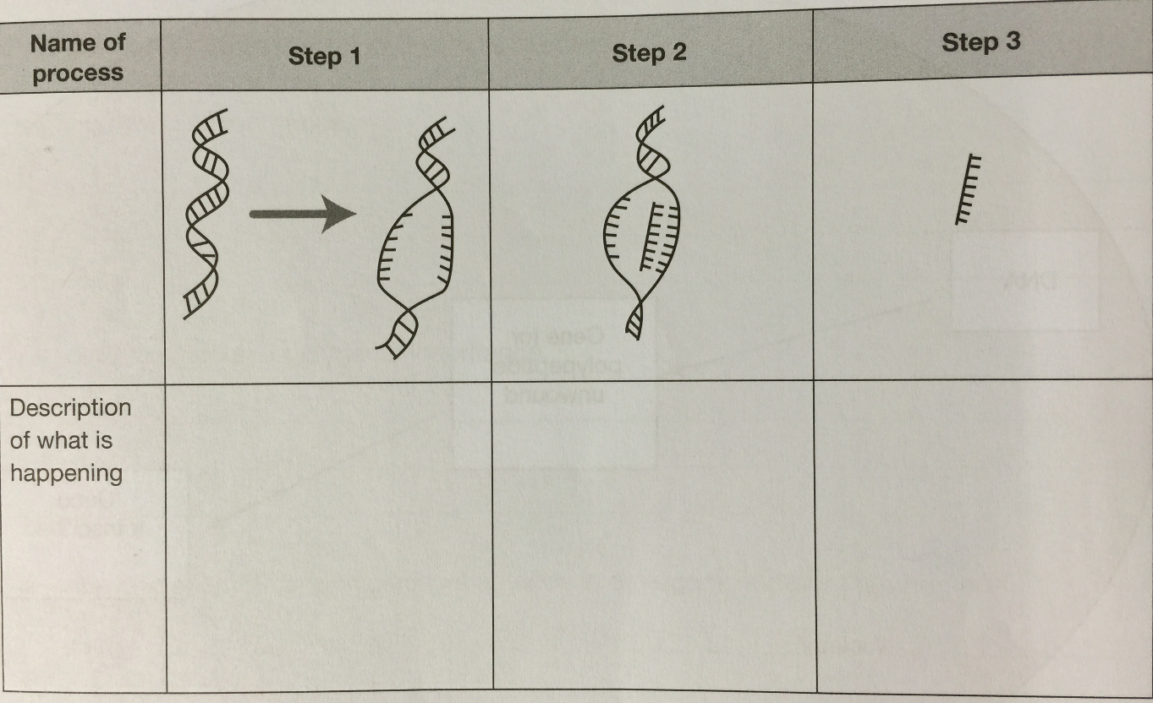

9. Define the following terms in relation to protein synthesis.

Promoter Gene:

__________________________________________________________________________________

__________________________________________________________________________________

Regulator Gene:

__________________________________________________________________________________

__________________________________________________________________________________

Structural Gene:

__________________________________________________________________________________

__________________________________________________________________________________

Anti-codon:

__________________________________________________________________________________

__________________________________________________________________________________

Codon:

__________________________________________________________________________________

__________________________________________________________________________________

(5 marks)

**CONTINUE TO NEXT PAGE**

**EXTENDED ANSWER**

9. Describe the process of RNA splicing. (9 marks)

__________________________________________________________________________________

__________________________________________________________________________________

__________________________________________________________________________________

__________________________________________________________________________________

__________________________________________________________________________________

__________________________________________________________________________________

__________________________________________________________________________________

__________________________________________________________________________________

__________________________________________________________________________________

__________________________________________________________________________________

__________________________________________________________________________________

__________________________________________________________________________________

__________________________________________________________________________________

__________________________________________________________________________________

__________________________________________________________________________________

__________________________________________________________________________________

__________________________________________________________________________________

__________________________________________________________________________________

__________________________________________________________________________________

__________________________________________________________________________________

__________________________________________________________________________________

__________________________________________________________________________________

__________________________________________________________________________________

__________________________________________________________________________________

__________________________________________________________________________________

__________________________________________________________________________________

__________________________________________________________________________________

__________________________________________________________________________________